**Capita Selecta Module one Yinqi Liang (R0865008)**

Task 1

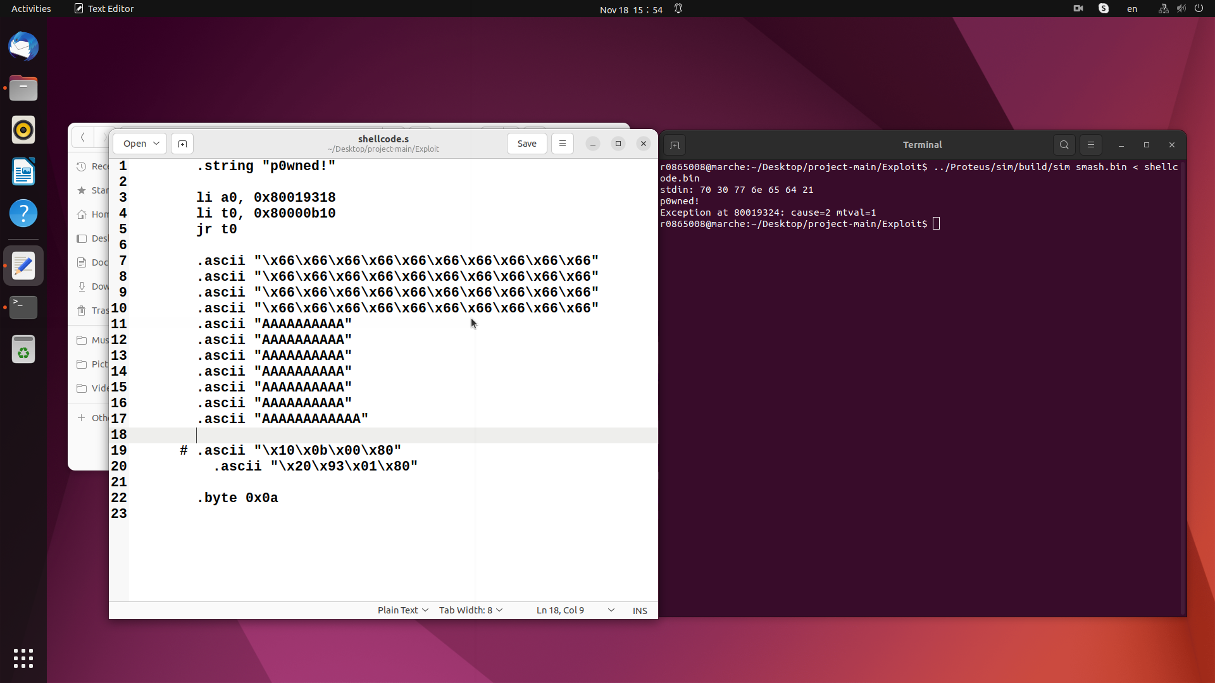When the smash_this() is called, its return address is push to the call stack, and then the buf[] is allocated above the return address. The c code gets() function does not check the length of the input string, thus this program is vulnerable to buffer overflow attack, by giving an input string with length longer than the buffer length and then overwrite the return address in the call stack. First, the puts() address in memory could be check by < readelf -a smash.elf | grep puts >, which give the address 0x80000b10. The real buf[] size could be checked by manually trying to input different number of ‘A’, and finally 140 * ‘A’ is the maximum number that buffer could contain. The address of the buf[] could be check using c code < printf("%p\n", (void *) &buf); > , which is 0x80019318. The original return to lib attack which provides function argument right after the function address does not work in this setting, thus a new way need to be invented. Since the puts() output the string with which its address store in [a0] register and the string "p0wned!" is provided at the beginning of the buf[], <li a0, 0x80019318> is used to feed the string to puts() function. <li t0, 0x80000b10> is used to place the puts() address to [t0] register, and <jr t0> will jump to the puts() function address and execute the puts() function. Then the payload is filled with some random bytes until it reach the return address. The return address is overwrite with the address of the <li a0, 0x80019318> instruction. At the end of the payload, 0x0a byte is inserted to make sure the puts() function stop.

Task 2

To use the CryptoUnit component, first it needs to new a CryptoUnit in the build() function where the instruction logic is implemented. Then the default value should be given to all the val of CryptoUnit, if not it would give error. The riscv is a 32 bits system, thus the key length should be 32 bits. The key is hard code in this stage.

The encryption is performed when BU_WRITE_RET_ADDR_TO_RD is true and pipeline.data.RD value equals to 1. The input of pipeline.data.NEXT_PC is assigned to the CryptoUnit cu.value, the CryptoUnit processed result cu.result is then assigned to pipeline.data.RD_DATA as output. When the jumpService is triggered, it’s the function return. Thus the decryption code should be added around the jumpService.jump() execute. When the RS1 is 1 and RS2 is 0, the target should be decrypted. The operation type is set to DECRYPT and the target is assign to the cu.value, the jump target is then the decrypted result cu.result.

Task 3

To insert the new instruction, the inline assembly code is written to smash.c file to create the new instruction. The key is set before the smash() call, and is set to 0 after the smash(). First, the key is loaded to the x7 register using <li x7,Key_value>, and then use the <.word 32bit_machine_code> to make the RS1 pointing to x7 register by making the RS1 contains the value 7, which means the bits corresponding to RS1 is set to ‘00111’ and choose a new opcode for the new instruction. Then the configuration to the new instruction is added. The new instruction is an R-type instruction which only RS1 value is effective. Also a flag of whether the key is set is added. To store the key and to keep the key value in different stages, a normal register is used. Thus, a register is manually created and the value of RS1 is loaded to the created register, which is the key set by user. By determining whether the key is greater than 0, the program can decide whether to encrypt and decrypt the return address. After the assembly code insert to smash.c file, the address of the puts() function change, so it need to be rechecked. The shellcode is then adjusted by the new address of the puts() function, and other components remain the same. By changing the key value in smash.c file, one can manually control encryption and decryption.